Installation of Jenkins using shell scripting

1. Go to EC service and click on Launch instance.

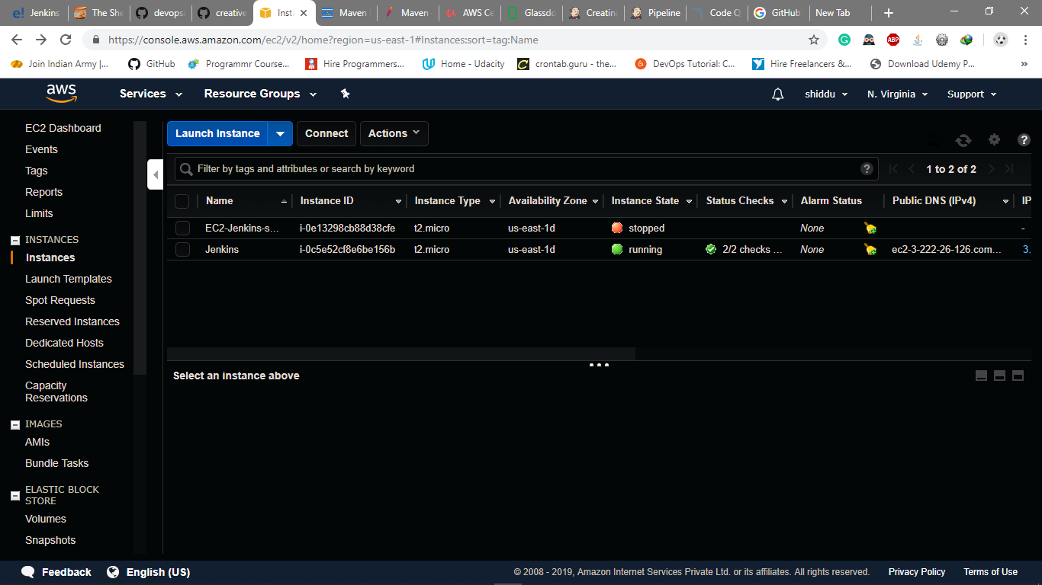

1. Select Ubuntu server 18.04LTS and click on select.

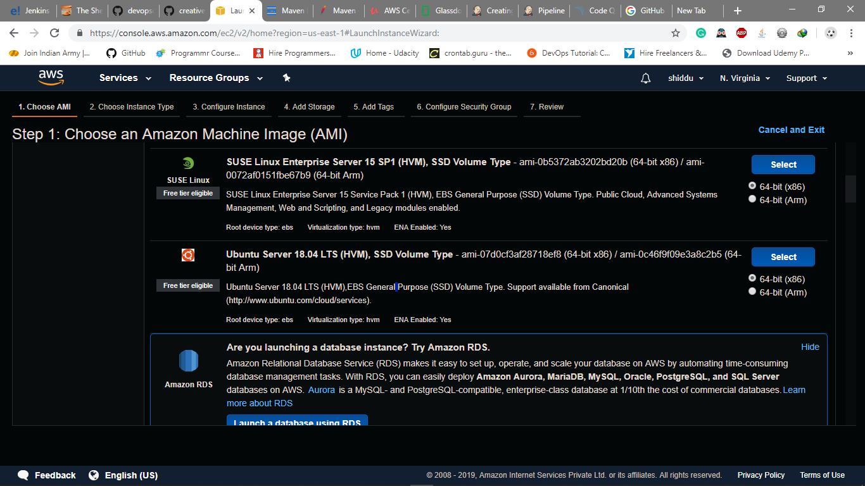

1. Select t2.micro type which is free tier eligible and click on

Configure instance details.

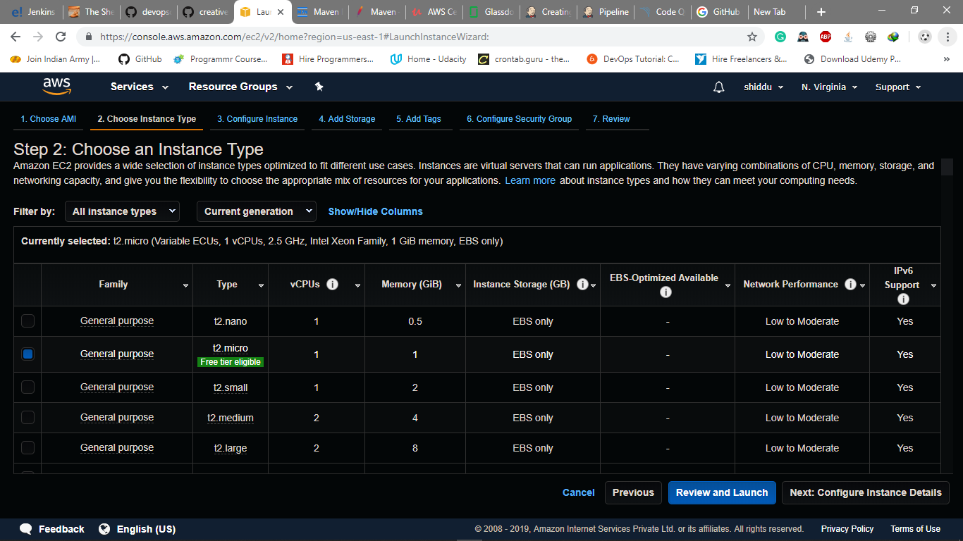

1. Let all the fields be default, scroll down and click on advance details, select user data as text and write the shell script in the provided workspace and click on add storage.

#!/bin/bash

#Install java

sudo apt-get update

sudo apt install openjdk-8-jdk -y

sudo chmod o+w /etc/environment

echo JAVA_HOME="/usr/lib/jvm/java-8-openjdk-amd64" >> /etc/environment

sudo chmod o-w /etc/environment

source /etc/environment

echo $JAVA_HOME

#Install jenkins

sudo wget -q -O - https://pkg.jenkins.io/debian/jenkins-ci.org.key | sudo apt-key add -

echo deb https://pkg.jenkins.io/debian-stable binary/ | sudo tee /etc/apt/sources.list.d/jenkins.list

sudo apt-get update

sudo apt-get install jenkins -y

sudo systemctl start jenkins

sudo systemctl status jenkins

#Install maven

sudo apt-get update -y

sudo apt-get upgrade -y

cd /opt/

sudo wget https://www-eu.apache.org/dist/maven/maven-3/3.6.1/binaries/apache-maven-3.6.1-bin.tar.gz

sudo tar -xvzf apache-maven-3.6.1-bin.tar.gz

sudo mv apache-maven-3.6.1 maven

sudo rm apache-maven-3.6.1-bin.tar.gz

sudo touch /etc/profile.d/mavenenv.sh

sudo chmod o+w /etc/profile.d/mavenenv.sh

echo export M2_HOME=/opt/maven export PATH=${M2_HOME}/bin:${PATH} > /etc/profile.d/mavenenv.sh

sudo chmod ugo+x,o-w /etc/profile.d/mavenenv.sh

source /etc/profile.d/mavenenv.sh

sudo apt install maven -y

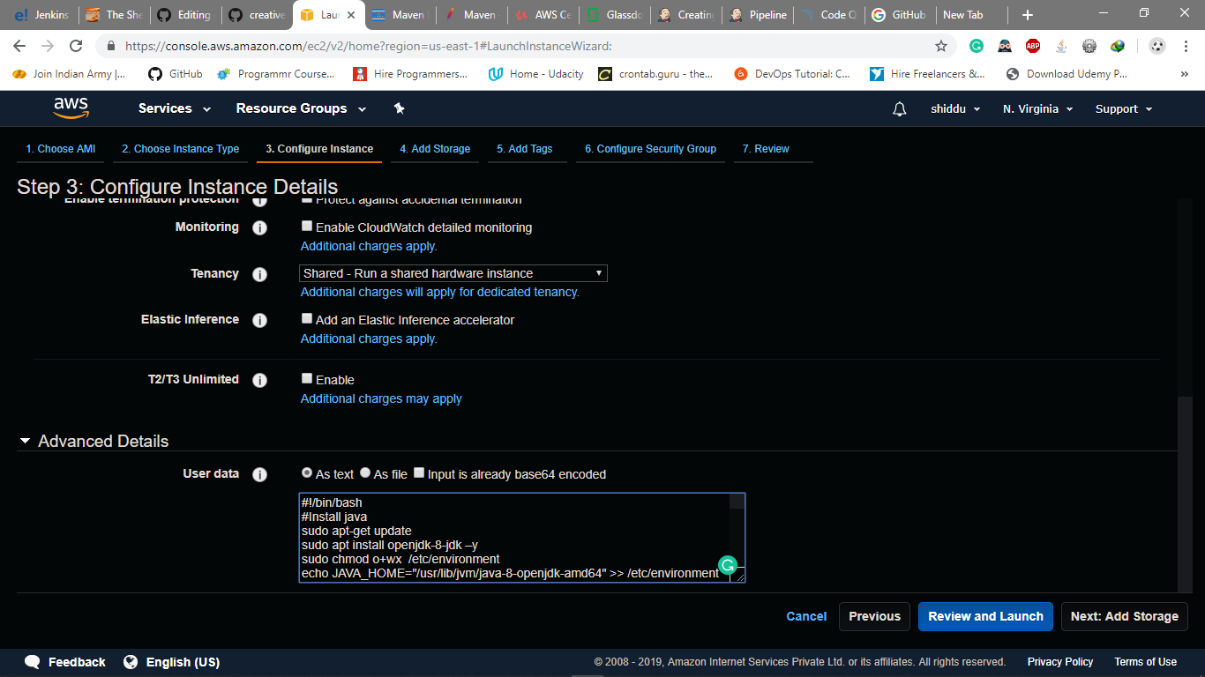

1. You can select the required storage in this case let it be default

And click on add tags.

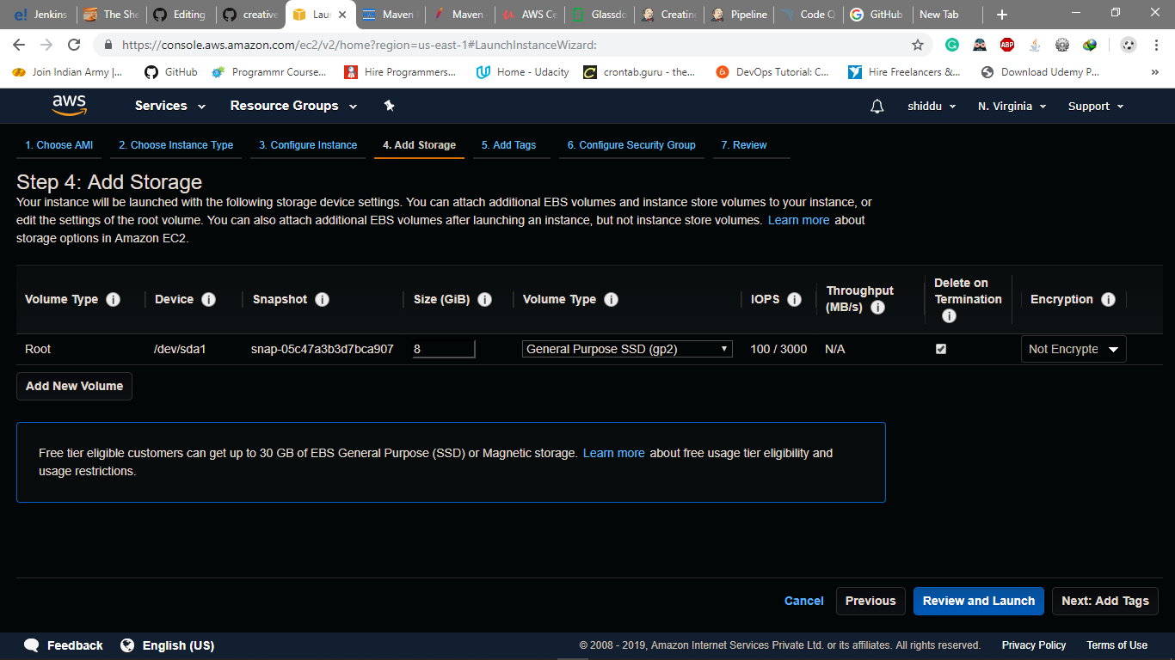

1. Click on add tag, tag is nothing but giving any name to your instance give any name to your instance and click on configure security group.

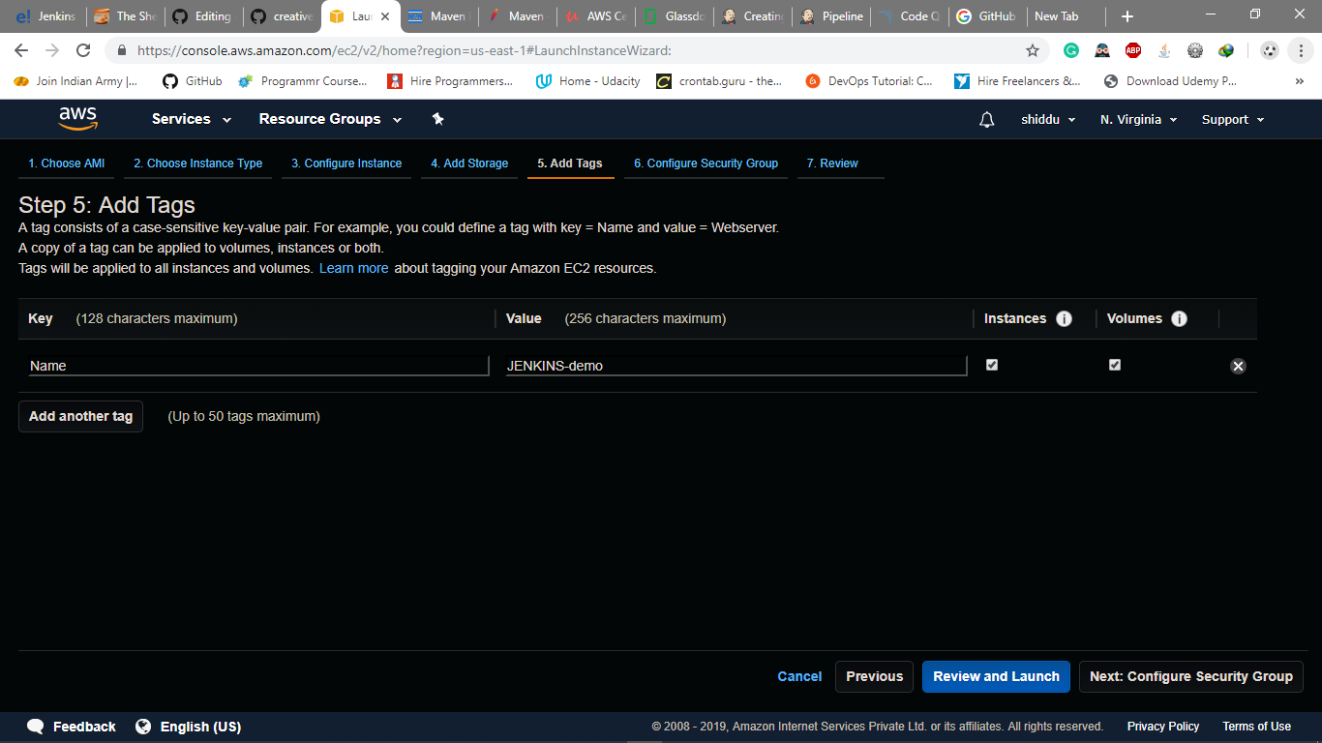

1. Select the required security group

* SSH port no 22 to connect to shell.
* Custom TCP port no 8080 default port of Jenkins.
* Custom TCP port no 50000 default port of slave Jenkins.

You can select source as anywhere to run the service in any system.

Click on review and launch

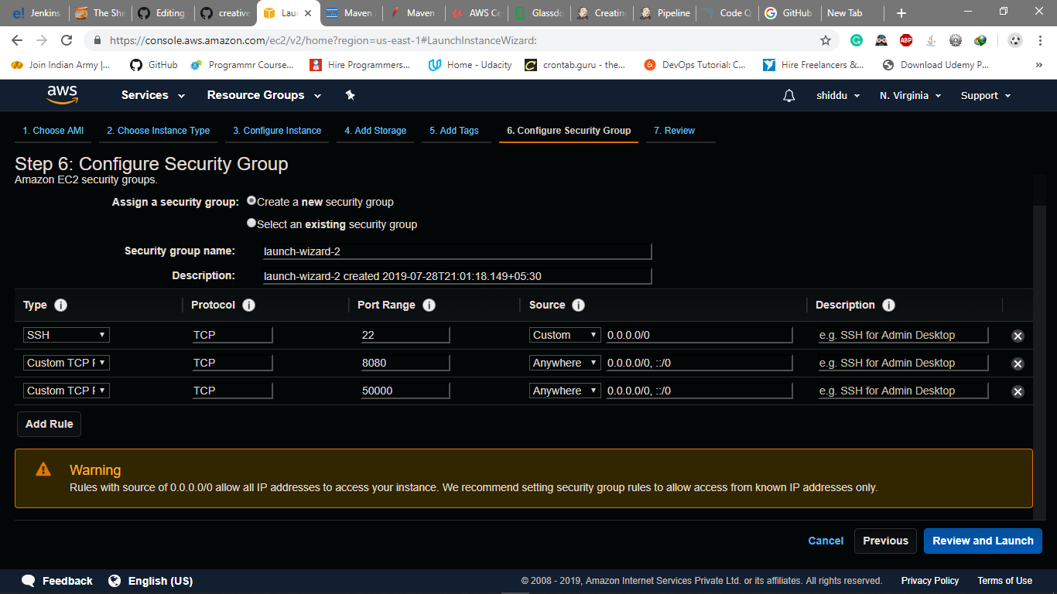

1. You can review the instance here and click on launch.

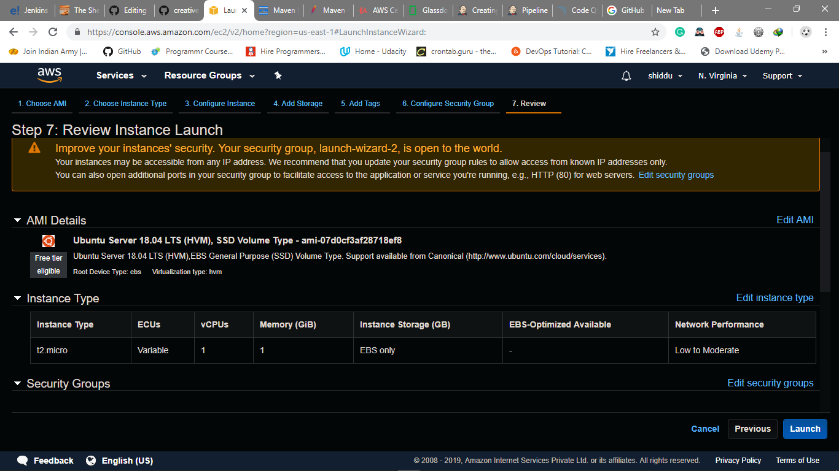

1. If the key pair exists select the choose an existing key pair, if not create a new key pair, give key pair name and download key pair and click on launch instance.

